Aero Tides: Rowdy Ascension
Web
Description | My feed is full of people showing off Legendary Dolphin Rowdy. Meanwhile, I'm sitting on 40 Aero Gems and a collection full of question marks. I've been watching some YouTube tutorials on how to hack games with databases but can't understand them. I know you got me. Get me that Dolphin Rowdy!!!
Files | Docker Compose: one game container and one private PostgreSQL container in challenge/. From this folder:  cd challenge  cp .env.example .env  Set POSTGRES_PASSWORD, VULN_DB_PASSWORD, and SESSION_SECRET in .env. Keep the supplied flag, seed, and flag-prefix values. Then start the stack:  docker compose -p gatcha-review up --build -d  Open http://localhost:18112. Give players only the event URL and these credentials: TheOriginalAppleJuice / ShoutoutJohnCena@123!. Keep the source, containers, organizer files, and these submission documents private. Maintenance: organizer/OPERATIONS.md.
Hint(s) | None.
Walkthrough | The intended solve restores the player's wallet through a stored-input trust-boundary flaw, then uses genuine summons to obtain Dolphin Rowdy's message. The outline below covers the reasoning and normal game controls; it does not reproduce the injection procedure.  1. Select Enter Event and sign in with the supplied account. The Summon screen shows 40 gems; one pull costs 100.  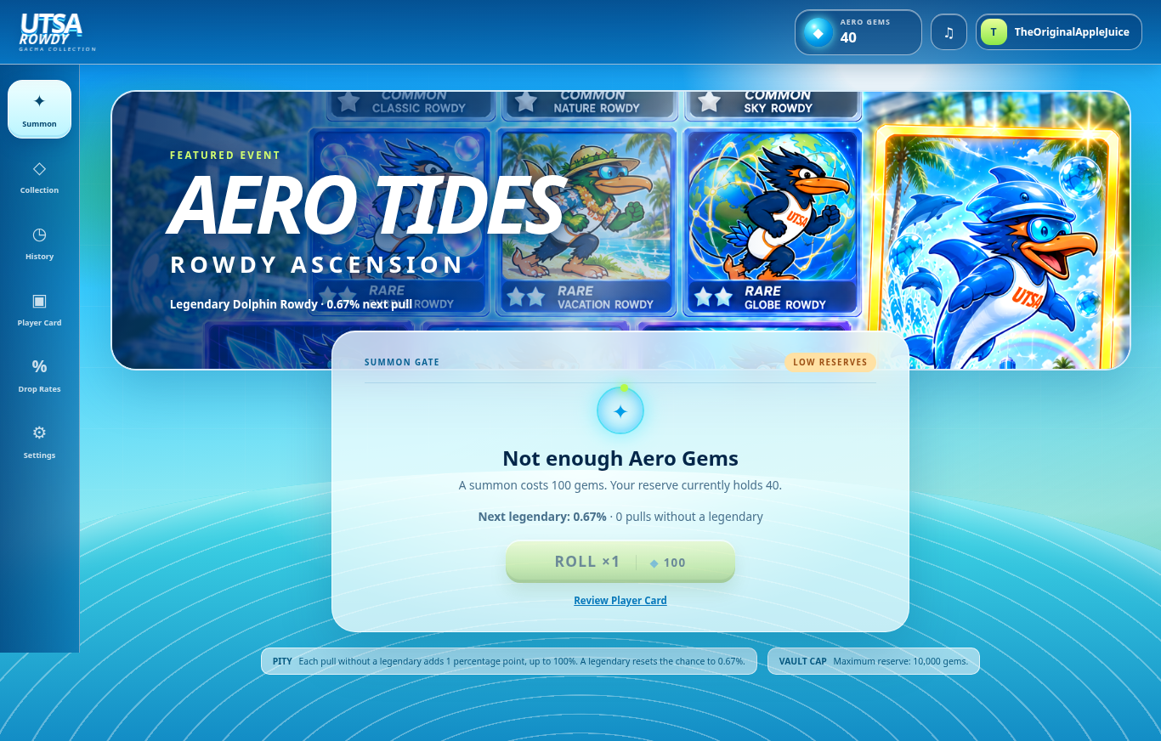  2. Open Player Card. Saving and synchronization are separate actions. The flaw occurs when synchronization treats stored motto text as database instructions. The intended result is a funded wallet.  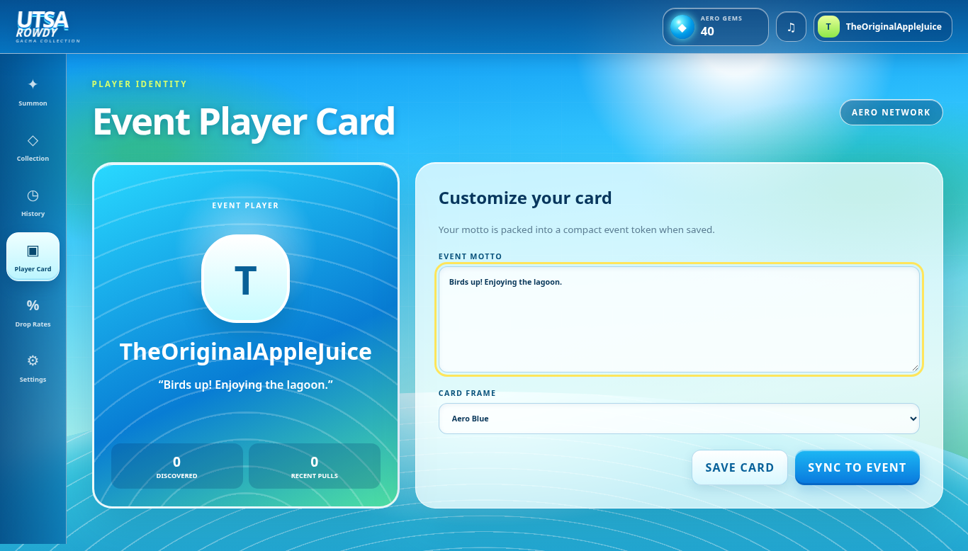  3. Return to Summon and select Roll ×1. Each pull costs 100 gems. Legendary odds start at 0.67%; each nonlegendary adds one percentage point (1.67%, 2.67%, …), capped at 100%. A legendary resets the chance to 0.67%. Pity persists between visits.  4. When Legendary Dolphin Rowdy appears, read its message. Select Copy Message, or reopen the message in History.
Flag | RCC{g0ld3n_t1d3_d0lph1n_r0wdy}

